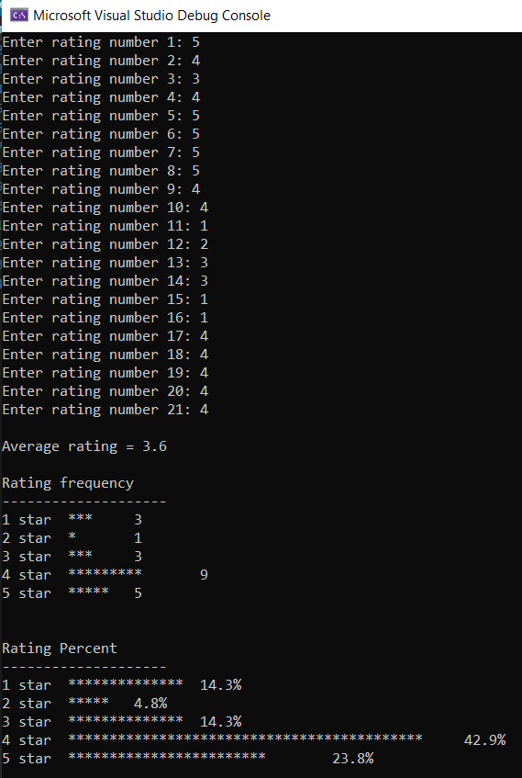

Full code

/*

Maxwell Maia

21236277

2 November 2021

*/

#include <stdio.h>

#include <math.h>

void main()

{

int i = 0;

int rating[21];

int tempRating = 1;

float totalRating = 0.0;

float averageRating = 0.0;

int ratingFrequency[5] = { 0,0,0,0,0 };

//read in ratings

for (i = 0; i < 21;)

{

printf("Enter rating number %d: ", i + 1);

scanf_s("%d", &tempRating);

if (tempRating > 0 && tempRating < 6) //only allow input of numbers 1 - 5

{

rating[i] = tempRating; //add rating to array of ratings

totalRating = totalRating + rating[i]; //sum ratings (will to calculate average later)

switch (rating[i]) //increment the rating frequency array depending on the number (1-5)

{

case 1:

ratingFrequency[0] = ratingFrequency[0] + 1;

break;

case 2:

ratingFrequency[1] = ratingFrequency[1] + 1;

break;

case 3:

ratingFrequency[2] = ratingFrequency[2] + 1;

break;

case 4:

ratingFrequency[3] = ratingFrequency[3] + 1;

break;

case 5:

ratingFrequency[4] = ratingFrequency[4] + 1;

break;

default: printf("\nError: default is printed in switch case\n");

}

i++;

}

else

{

printf("\nRating is a number from 1 - 5 stars.\n");

}

}

//average rating

averageRating = totalRating / i; //calculate

printf("\nAverage rating = %0.1f", averageRating); //display

printf("\n\nRating frequency\n--------------------\n");

//printing the rating frequency of 1 star ratings

int a = 0;

printf("1 star\t");

for (a = 0; a < ratingFrequency[0]; a++) //print a star for every 1 star rating made

{

printf("*");

}

printf("\t%d\n", a);

//printing the rating frequency of 2 star ratings

int b = 0;

printf("2 star\t");

for (b = 0; b < ratingFrequency[1]; b++) //print a star for every 2 star rating made

{

printf("*");

}

printf("\t%d\n", b);

int c = 0;

printf("3 star\t");

for (c = 0; c < ratingFrequency[2]; c++) //print a star for every 3 star rating made

{

printf("*");

}

printf("\t%d\n", c);

int d = 0;

printf("4 star\t");

for (d = 0; d < ratingFrequency[3]; d++) //print a star for every 4 star rating made

{

printf("*");

}

printf("\t%d\n", d);

int e = 0;

printf("5 star\t");

for (e = 0; e < ratingFrequency[4]; e++) //print a star for every 5 star rating made

{

printf("*");

}

printf("\t%d\n", e);

printf("\n\nRating Percent\n--------------------\n");

//printing the rating percentage is the same process as before, but the amount of stars is calculated as a percentage and rounded

printf("1 star\t");

for (a = 0; a < (round((ratingFrequency[0] / 21.0) * 100)); a++) //print a star for the percentage 1 star of ratings made

{

printf("*");

}

printf("\t%0.1f%%\n", (ratingFrequency[0] / 21.0) * 100);

printf("2 star\t");

for (b = 0; b < (round((ratingFrequency[1] / 21.0) * 100)); b++) //print a star for the percentage 2 star of ratings made

{

printf("*");

}

printf("\t%0.1f%%\n", (ratingFrequency[1] / 21.0) * 100);

printf("3 star\t");

for (c = 0; c < (round((ratingFrequency[2] / 21.0) * 100)); c++) //print a star for the percentage 3 star of ratings made

{

printf("*");

}

printf("\t%0.1f%%\n", (ratingFrequency[2] / 21.0) * 100);

printf("4 star\t");

for (d = 0; d < (round((ratingFrequency[3] / 21.0) * 100)); d++) //print a star for the percentage 4 star of ratings made

{

printf("*");

}

printf("\t%0.1f%%\n", (ratingFrequency[3] / 21.0) * 100);

printf("5 star\t");

for (e = 0; e < (round((ratingFrequency[4] / 21.0) * 100)); e++) //print a star for the percentage 5 star of ratings made

{

printf("*");

}

printf("\t%0.1f%%\n", (ratingFrequency[4] / 21.0) * 100);

}